Building AI Test Agents Using Playwright MCP Server

Introduction
Modern applications evolve rapidly.This requires faster and smarter testing strategies. Traditional automation frameworks rely on predefined scripts, which makes them rigid and difficult to adapt to changing application behavior.
With the rise of AI-driven development, testing frameworks must also evolve.
Playwright MCP Server allows AI agents to interact with applications through browser automation.
Playwright MCP (Model Context Protocol) Server enables AI agents to interact with applications through browser automation. By integrating AI decision-making with Playwright automation, teams can build intelligent testing workflows capable of performing UI testing, API validation, application health checks, and automated reporting with minimal human intervention.

What is Playwright?
Playwright is an open-source automation framework developed by Microsoft for testing modern web applications.
It supports Chromium,Firefox,WebKit (Safari engine)
Key features:
✔ Cross-browser testing
✔ Fast parallel execution
✔ Auto waiting and smart selectors
✔ Built-in API testing
✔ Screenshot & trace capturing
Playwright is widely used for end-to-end testing, regression testing, and UI automation.

What is MCP (Model Context Protocol)?
Model Context Protocol (MCP) is a framework that allows AI agents to communicate with external tools and services.
In simple terms:
AI Agent → MCP Server → Tool / Automation Framework
The MCP server acts as a bridge between AI systems and external automation tools.
This means an AI agent can:
- Run Playwright tests
- Navigate applications
- Capture screenshots
- Validate APIs
- Generate reports
without writing manual scripts every time.

Prerequisites
To implement a Playwright MCP Server, the following tools are required:
- Node.js installed
- Playwright MCP package
- AI Agent environment (such as Continue, OpenAI agent, or custom AI workflow)
- Access to application under test

What is a Playwright MCP Server?
A Playwright MCP Server exposes Playwright automation capabilities through an MCP interface so that AI agents can control browsers programmatically.
It allows AI-driven workflows such as:
• Automated smoke testing after deployment
• Application health checks
• Intelligent regression testing
• Automated navigation testing
• Screenshot-based validation
• API availability verification

Example workflow:

Build Deployment Completed
↓
AI Agent Triggered
↓
MCP Server Invokes Playwright
↓
Login → Navigate → Validate Pages
↓
Capture Screenshots + API Checks
↓
Generate Health Report

Example MCP Server Configuration
Below is an example configuration for a Playwright MCP server(YAML file).

name: Sanity Health Check MCP server
version: 0.0.1
schema: v1
envFile: "C:\\Users\\userId\\Documents\\Test\\.continue\\mcpServers\\.env"
mcpServers:
- name: Playwright MCP server
command: "C:\\Program Files\\nodejs\\npx"
args:
- "C:\\Users\\userId\\Documents\\node_modules\\.bin\\playwright-mcp.cmd"

Key Configuration Elements
name:Defines the MCP server name.
envFile:Contains environment variables such as:
- credentials
- API URLs
- tokens
command:Node command used to execute the Playwright MCP server.
args:Path to the Playwright MCP executable.

How Playwright MCP Helps in Test Automation

1. Automated Smoke Testing
After a build deployment, the AI agent can automatically:
- Open application
- Login
- Navigate key modules
- Verify UI loads correctly
This ensures immediate build validation.

2.Screenshot-Based Validation
Playwright allows capturing screenshots during execution.
The MCP agent can:
- capture screenshots
- compare UI states
- store reports
This helps with visual regression testing.

3. API Testing
Playwright also supports API testing.
The MCP server can:
- validate backend APIs
- check response codes
- verify response structure
This allows UI + API testing from a single framework.

4. Intelligent Test Execution
With AI integration, tests are no longer static.
Agents can:
- dynamically explore application pages
- retry failures
- detect navigation errors
- generate debugging logs

Architecture of AI-Driven Testing using MCP
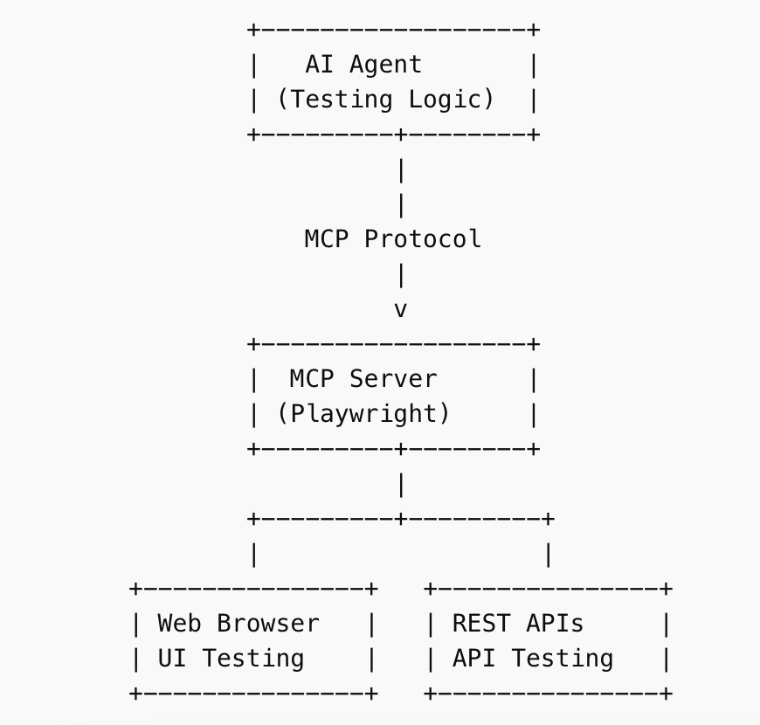

Architecture Explanation
The architecture consists of four main components:
- AI Agent
  - Contains testing logic and decision-making capability.
  - Sends instructions to the MCP server.
- MCP Protocol
  - Acts as the communication layer between AI and automation tools.
- Playwright MCP Server
  - Receives commands from the AI agent.
  - Executes browser automation and API validations.
- Execution Layer
  - Web browser automation for UI testing
  - REST API testing for backend validation
This layered architecture allows AI agents to perform intelligent testing workflows.

Benefits of Playwright MCP Server

1. Fully Automated Testing:
Testing becomes AI-driven instead of script-driven.

2. Faster Feedback for Developers
Smoke tests run immediately after deployment.

3. Reduced Manual Effort

No need to manually trigger tests.

4. Intelligent Issue Detection
AI agents can identify failures faster.

5. Scalable Automation
Multiple MCP agents can run tests across different environments.

Real-World Use Case
Consider an Application deployed across multiple environments.
Using Playwright MCP:
The AI agent performs:
- Login to the application
- Navigate to audit modules
- Validate important pages
- Verify APIs are working
- Capture screenshots
- Generate health reports
If any page fails, the system reports the issue automatically.

Future of AI-Driven Testing
Playwright MCP is an important step toward the future of autonomous quality engineering..
Future capabilities may include:
- Self-healing tests
- AI-generated test cases
- Autonomous exploratory testing
- Intelligent defect detection
This will significantly reduce the need for manual scripting.
​​Conclusion
The Playwright MCP Server represents a powerful shift toward intelligent test automation. By combining Playwright's robust browser automation capabilities with AI agents through the Model Context Protocol, organizations can build testing systems that are adaptive, scalable, and autonomous.
As AI-driven software development grows, integrating automation frameworks with AI agents will become a key strategy for delivering high-quality applications faster and more reliably.
Playwright MCP is an important step toward the future of autonomous quality engineering.
By combining Playwright's browser automation capabilities with MCP's AI communication layer, teams can create intelligent testing systems capable of performing:
- UI testing
- API validation
- application health checks
- automated smoke testing
- screenshot-based monitoring
This approach moves testing towards a fully autonomous AI-driven quality engineering model.

